Identifying Corners in a Simple Environment using a 360 Degree 2-Dimensional Lidar Sensor
By Noah Haskell

Autonomous systems are often used in both indoor and outdoor environments for a wide variety of purposes including as agriculture, search and rescue, and high-school robotics competitions. All of these systems must be able to autonomously navigate an environment. In recent years a low-cost LIDAR range-finder has been made available in the Neato XV-11 All-Floor Vacuum System, which is suitable for use in a high-school robotics team environment. This paper will attempt to develop a simple algorithm to detect corners in the environment. This is the first step to using this sensor for autonomous navigation. The eventual goal of this research is for the sensor to be usable by any FRC robotics team with little difficulty.

Introduction:

Autonomous systems are often used in both indoor and outdoor environments for a wide variety of purposes including as agriculture, search and rescue, and high-school robotics competitions. All of these systems must be able to autonomously navigate an environment (Konolige, Augenbraun, Donaldson, Fiebig, & Shah, 2008). Various systems have been used in the past for this purposes. GPS systems do not have the precision needed and require a precise layout of the building. Computer vision systems that rely on cameras require large amounts of processing power and are affected by changes in light level (Wilson, 2000). One of the most accurate sensors for this purpose is a LIDAR range-finder.
In recent years a low-cost LIDAR range-finder has been made available in the Neato XV-11 All-Floor Vacuum System (Neato Robotics, n.d.). This sensor consists of an infrared laser and receiver mounted on a rotating base, and can measure the distances of surfaces on a 2d plane within 6 meters with 2cm accuracy (Konolige et al., 2008). This sensor is readily available, and can easily be modified to connect to a computer via USB (Mason, 2014).
The low cost of this sensor makes it suitable for use in a high-school robotics team environment. The data from this sensor can give the team an extreme advantage during autonomous play periods. This paper will attempt to develop a simple algorithm to detect corners in scans of the environment taken by the sensor. This is an important step to autonomously navigating an environment, as detecting key points such as corners is an important part of many autonomous mapping algorithms.
The system used will be the LIDAR sensor connected to a laptop running a program converting raw data from the sensor to an array sent via network tables to a separate NI LabVIEW program which detects corners in the environment.
The eventual goal of this research aims to use a low-cost LIDAR sensor for autonomous navigation of areas with obstacles, and to be able track moving obstacles and avoid them. Detecting corners is an important step on the way to detecting change in the environment.

Methods:

Overview:

A 360 degree two-dimensional LIDAR range finder will be placed inside the testing environment, consisting of a 4 sided box with a concave corner, as seen in figure 1. The LIDAR will scan the environment, generating a set of polar coordinates. The scan will then be run through an algorithm to highlight corners in environment based on the angle of secant lines between points.

Figure 1: The LIDAR sensor in the Environment. The walls are constructed out of polycarbonate with plain white paper taped on top of it. The convex corner in the upper right is constructed out of Lego bricks. 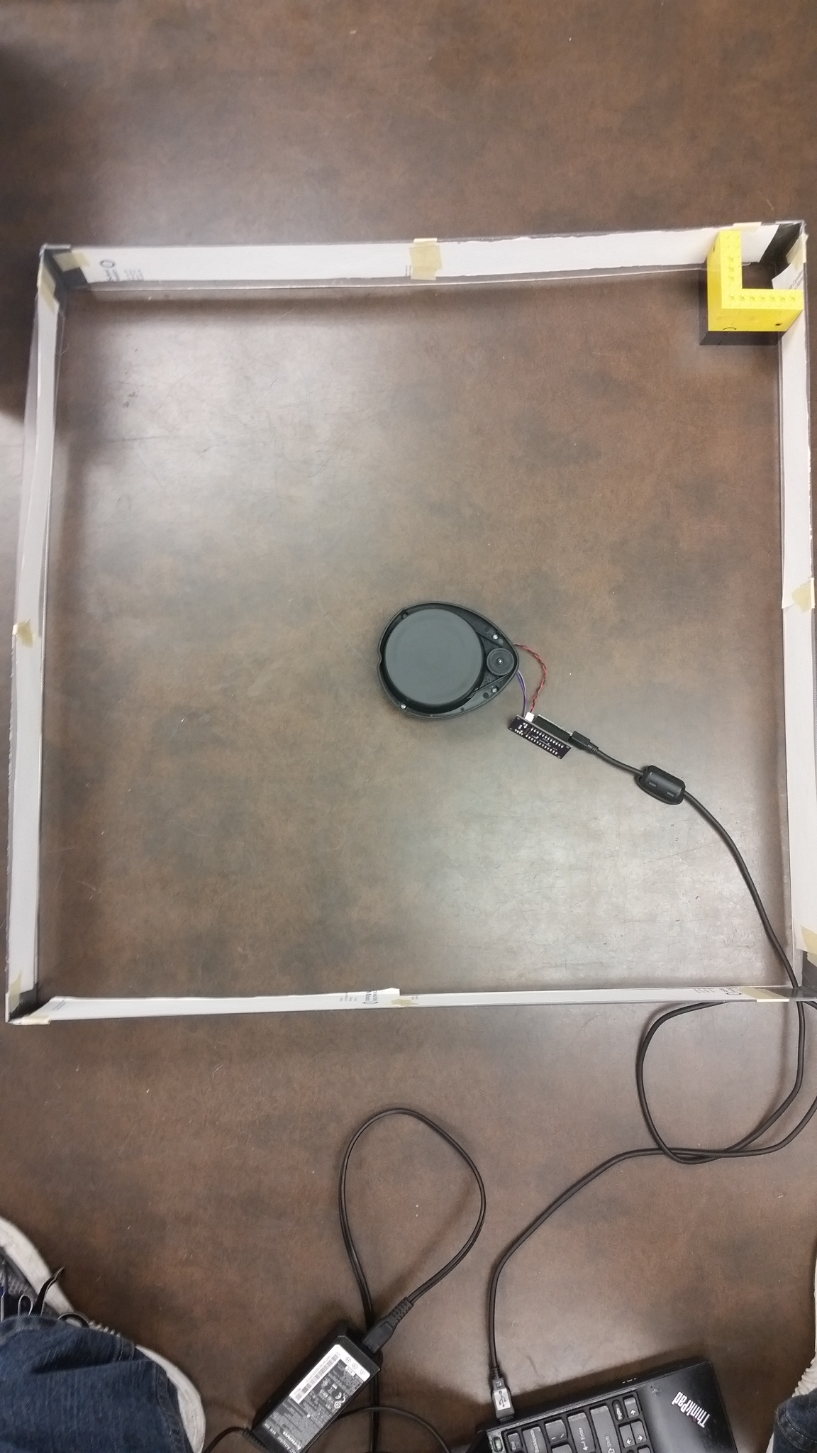

Measurements:

The sensor being used is the Revo sensor taken from a NEATO-XV11 robotic vacuum cleaner. A white paper published on the sensor in 2008 shows that the sensor has an accuracy of 3 cm at 6 a distance of 6 meters, and scans at a frequency of 10Hz. Testing has shown that the actual maximum distance from the sensor that an object can be detected is dependent on the material makeup of the surface of the object.
The sensor will scan its surroundings, and save a scan as a set of polar coordinates. These coordinates will be converted to Cartesian and analyzed in order to determine corners in the environment. Corners are defined as places where the angle created by 3 consecutive points is between 45 degrees and 135 degrees. One point (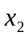) is defined as the origin, with two vectors originating at that point and going through the other two points. According to the dot product rule,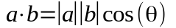. Thus:

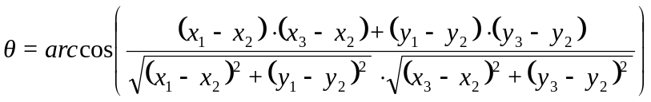

Where is the angle between the two vectors.

Experimental Design:

3 scans will be taken with slight changes in the environment to determine the number of false positives and false negatives.

Experimental Procedure:

Program design:
- Translate binary data from the sensor to Polar coordinates
- Convert Polar to Cartesian coordinates
- Callable function to record data from 0 degrees to 359 degrees
- Design algorithm as detailed above to detect corners.
- Store the data from two scans as one set of data.

Testing Phase:
- The sensor will be placed in the environment.
- Multiple scans will be recorded, with the algorithm marking corners
- The number of corners found will be compared to the actual number of corners of the environment, and the number of false positives and negatives reported.

Data:

Overview:
In order to test the accuracy of this algorithm, 3 different sets of data were taken, with points identified as corners marked in blue.
Note that the corners identified on the first and last points in each scan are invalid. This is an artifact of the algorithm requiring a point directly before and after in the array, and can be resolved by checking if the first or last point is used and using the data from array position 360 instead of 0 and 1 instead of 361. This problem will be fixed for future usage, but for now these points should be ignored.

Measurements:
The three scans taken are shown in Figures 2-4. The LIDAR was placed into the approximate center of the environment at a semi-random angle and the outline of the enclosure is revealed as a series of measurement points. The curvature of the sides of the scan is due to the natural flex in the material used to make the testing environment. Each scan is an array of 360 different clusters of 4 values each constituting a point on the plot and consisting of the raw data from the sensor indicating the location of that point (magnitude in millimeters and phase in degrees), as well as the calculated angle between that point and its adjacent points, and a Boolean identifying whether or not the calculated angle is a corner. Points identified as corners are also highlighted blue on the scans. Figures 1 through 3 show the environment which the Lidar was placed in including the four walls and the convex movable corner. Figure 5 shows two different examples of clusters of data.

Figure 2: A scan taken, with an unexplained gap in the bottom of the environment.
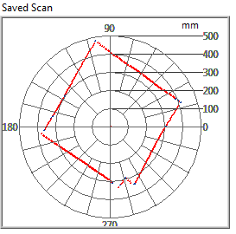

Figure 3: Scan taken in a non-square environment.
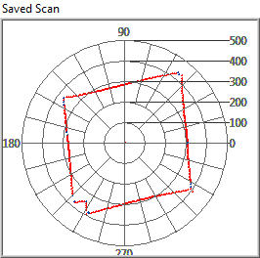

Figure 4: Scan taken with a large gap in the corner.
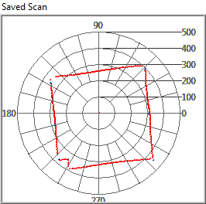

Figure 5: Two different sets of data, one identified as a corner.
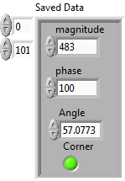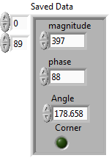

Calcualted Data:
In order to test the robustness of this method, the number of corners that were detected that were not part of actual corners (corners detected – actual number of corners (6)) will be compared to the number of points taken by the scan to calculate the regularity of false positives. Figure 6 shows an annotated list of all of the points in Figure 2.

Figure 6: Corners identified in Figure 1
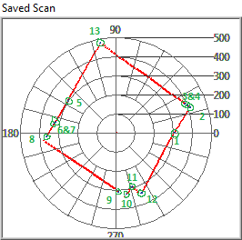
- This point is the first point in the scan, and is not correctly identified as a corner, as discussed earlier in the section, and will be subtracted from the total number of detected points.
- Valid corner.
- Invalid corner, created by a gap between 3&4.
- Invalid corner, created by a gap between 3&4.
- Invalid corner, created due to unknown circumstances
- Invalid corner, created by a gap between 6&7.
- Invalid corner, created by a gap between 6&7.
- Near a valid corner, although the actual corner is not hilighted. This is not expected, and we be investigated with further research, and is a false negative.
- Near a valid corner, in conjunction with 10. This is similar to corner 8.
- Near a valid corner, in conjuction with 9. This is similar to corner 8.
- Valid corner.
- Valid corner.
- Valid corner
Table 1: Number of Corners Detected and False Positive and Negatives rates
Scan | Corners | False Positives | False Positives Rate (out of 360) | False Negatives | False Negatives Rate (out of 6)
1 | 12 | 6 | 1.67% | 2 | 33%
2 | 13 | 7 | 1.94% | 2 | 33%
3 | 9 | 3 | 0.833% | 1 | 16%

In all three scans, there are examples of invalid corners which were created on the sides of the environment. The exact cause of this is unknown, and needs further investigation.

Analysis:

All of the scans taken identified a point at each of the different corners around the border of the testing environment. However, each scan also identified corners at various points around the proximity of the environment. Additionally, not all of the corners identified were the center point of the corner that was identified, as was to be expected.
Corners identified along the edge of the environment are likely due to invalid data points, which the sensor reports back as a distance of 0. This creates an approximately right angle with the points on the side of the environment, making the point qualify as a corner. This explains the high rate of false positives
Application:

The data shows that this method has the ability to successfully detect corners in an environment with some degree of accuracy, although it does not always successfully detect the corner directly. Also, many other points along the edge of the environment are detected, but these can be removed by fine-tuning the algorithm and running the data through algorithm to remove these.

Conclusion:

This method for detecting corners is the basis for other, more accurate methods of modeling an environment and tracking movement. The ability to identify key points in the environment is an important component in most methods in navigating an environment. While the specific method presented in this paper was not the most robust, it did have the ability to detect corners in the environment. With time and refinement, this

Bibliography:

Konolige, K., Augenbraun, J., Donaldson, N., Fiebig, C., & Shah, P. (2008). A Low-Cost Laser Distance Sensor. Retrieved November 20, 2014, from http://www.robotshop.com/media/files/PDF/revolds-whitepaper.pdf
Mason, M. (2014). Using Neato Lidar. Retrieved November 17, 2014, from http://profmason.com/?p=13246
Neato Robotics. (n.d.). The Neato XV-11 All-Floor Vacuum System White Paper. Mountain View, CA.
Wilson, J. . (2000). Guidance of agricultural vehicles — a historical perspective. Computers and Electronics in Agriculture, 25(1-2), 3–9. doi:10.1016/S0168-1699(99)00052-6

